GUEST OF THE MONTH
October 2025

DANIEL GARCIA, EXECUTIVE DIRECTOR
SOUTHERN CALIFORNIA PUBLIC POWER AUTHORITY
CURRENT ACTIVITIES AND ACHIEVEMENTS
Summary by Robert Yoshimura
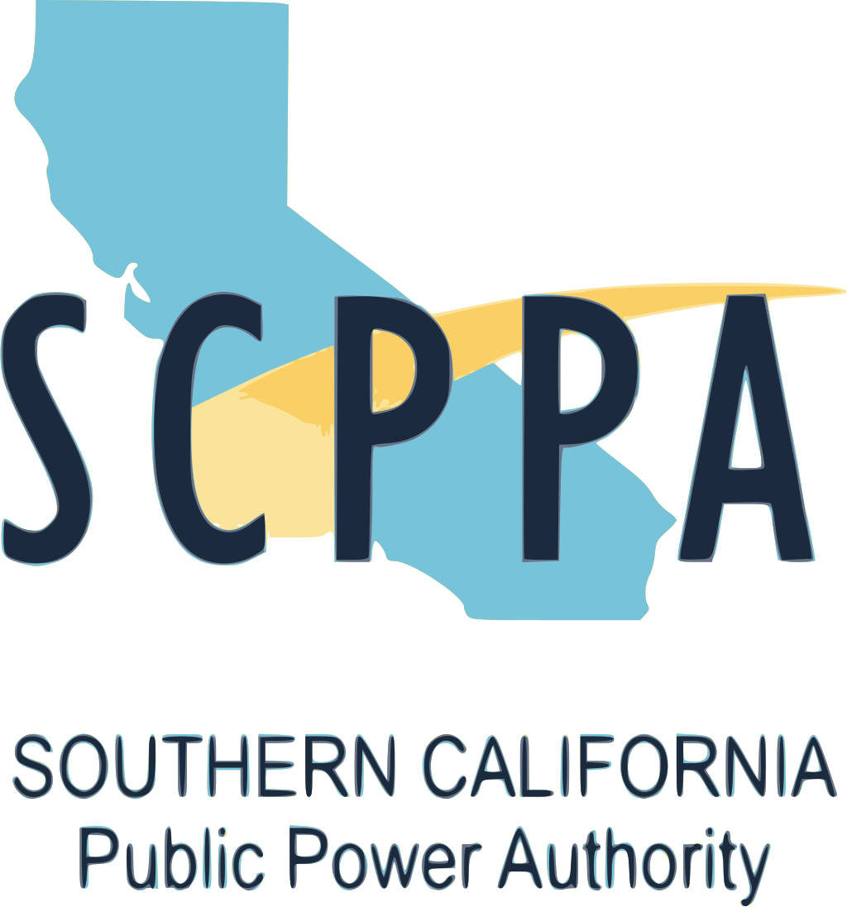

The Southern California Public Power Authority was established in 1980 and is celebrating its 45th anniversary this year. Its purpose is to provide joint planning, financing, construction, and operation of transmission and generation projects to benefit its 12 member agencies. The membership consists of 11 municipal utilities and one irrigation district.
The member agencies are shown in the box below.

The membership roster is fixed, and no new members will be added. However, SCPPA is considering associate memberships for Community Choice Aggregators who provide clean energy to many of the members.

SCPPA is governed by a 12-member board of directors. Each member agency is represented by its CEO or a designated utility company official. Governing documents include the Joint Exercise of Powers Act, a Joint Powers Agreement, By-laws, and resolutions adopted by the Board of Directors.
- City of Anaheim
- City of Azusa
- City of Banning
- City of Burbank
- City of Cerritos
- City of Colton
- City of Glendale
- Imperial Irrigation District
- City of Los Angeles
- City of Pasadena
- City of Riverside
- City of Vernon

Over the years since its inception, SCPPA’s project portfolio has grown to a total of 40 facilities located in nine western and southwestern states. The projects are heavily focused on generation but also include some storage and transmission facilities as well. Generation projects are largely renewable energy facilities such as solar, wind, and geothermal.

All of the member agencies are facing similar challenges that include decarbonization and the need to accommodate electrification, changing technology and aging infrastructure, maintaining affordability, loss of local control, an aging workforce, supply chain issues, and cybersecurity. SCPPA expects to play an important role in helping the member agencies to overcome those challenges.

Some of the member agencies have set timelines for achievement of renewable energy goals that are more ambitious than required by SB 100. However, Daniel anticipates that some adjustments to those timelines are likely because of the need to maintain affordability.

The member agencies’ transition to clean and renewable energy sources has changed SCPPA’s approach to procurement of such sources. SCPPA’s Board and key staff recently engaged in a discussion of strategic initiatives to define the clean energy landscape. That landscape is complex because of many factors. Resources and technologies are numerous and wide-ranging but SCPPA’s focus is guided by the need to be affordable, reliable, and clean. Technologies include solar and wind, biomass, landfill gas, geothermal, and hydropower. Two member agencies have also included nuclear in their integrated resources plans and feel that this is a viable alternative.

SCPPA is moving away from building its own facilities because of the emergence of private energy developers who have the advantage of economies of scale. Even so, the clean energy marketplace currently favors sellers, thus buyers are now asked to assume more of the risk of pricing, regulatory changes, supply chain issues, etc. Future procurement is likely to occur via Purchased Power Agreements (PPAs) rather than by construction of generation/transmission projects and member agencies will continue to receive pricing benefits from the joint procurement process.

SCPPA is currently working on 9 projects, mostly solar and wind, and mostly PPAs. Of the nine, 5 are in California, 3 in Utah, and 1 in Arizona. Additionally, 4 projects are effectively operational or are achieving their Commercial Operating Date (COD) which is the formal transition from construction to operation. There are also 14 renewable projects and nine stand-alone energy storage projects on SCPPA’s backup/shortlist for future development.

Projects that were recently extended or have achieved COD include Eland 1 and Eland 2, both of which are solar energy and storage projects located near Barren Ridge CA. Both projects combine 200 MW of AC solar generation with 150 MW/ 600 MWh of battery storage. The Heber 1 Geothermal project is an existing facility that was recently repowered for 52 MW of generation and its PPA has been extended for 25 years to 2052. It is in Imperial Valley CA. While SCPPA continues to seek stand-alone storage projects, there are no pumped-storage projects on their horizon.

The pricing outlook for new renewable energy projects is disappointingly high. Solar projects will cost from the mid $40s to the high $50s per MWh. Wind will cost over $100 per MWh. Because of political pressure to aggressively transition to renewable energy, the demand is high, and the previously mentioned seller’s market now drives prices in the renewable energy industry. Other factors contributing to such higher costs include rising property tax rates for solar development, elimination of federal tax credits, tariff volatility, permitting costs, and other such hurdles. Geothermal generation is still active in California, Nevada, and Utah, but pricing has increased compared to pre-pandemic levels. Battery Energy Storage System (BESS) costs range from the low $10s to the high $10s per KW-month. Unfortunately for SCPPA and the entire electric power industry, the transition to renewable energy is likely to cost more than now expected.

